Karthick B, 1912067

Last 3 Month Progress in technical learning

(April 1 to June 13)

**Skill rack Daily Challenge Solved** – 52/74 days

**Work made in GitHub** – 64/74 days

**Days without any technical learning or work-** 5 days

**Project works**

**Upload.io**- Deployed at upload.karthifairhawn.in

**URL Shortener**- Using Express, Postgres (Ongoing mini project)

**Simple Bootstrap Site for Mechanical Symposium**

**(Made some upgrades to old project)**

**Participated in Mistral Hackfest –** Proposed a concept for automated wildlife count.

Created a simple student management CRUD application using Servlet API and Postgres.

**Past 1 Year GitHub work**

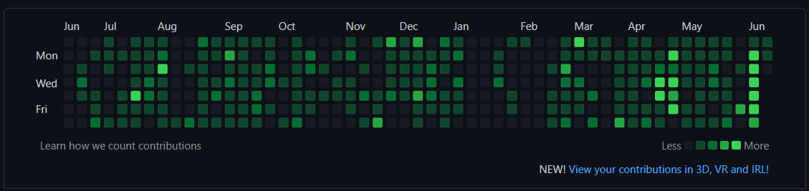

**April 1**

**Git Hub Work**

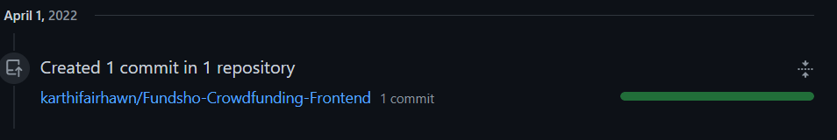

**Technical articles and blog read.**



**April 2**

**Git Hub Work**

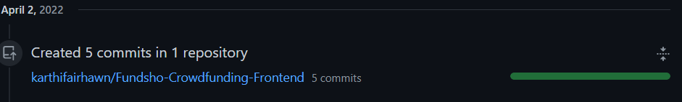

**Technical articles and blog read.**



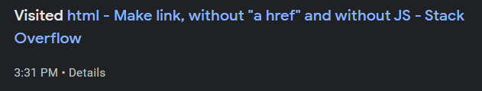





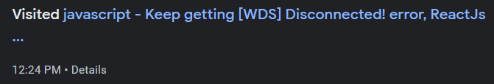

 



**April 3**

**Git Hub Work**

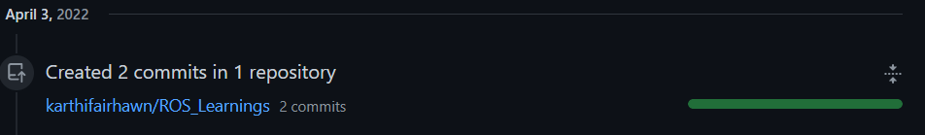

**Technical articles and blog read.**

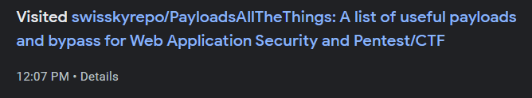

**April 4**

**Github Work**

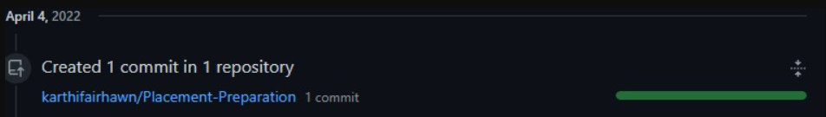

**Leetcode**



**Technical articles and blog read.**

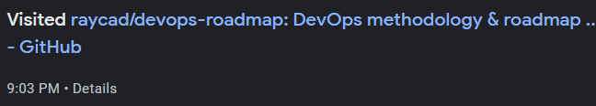

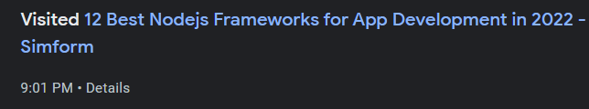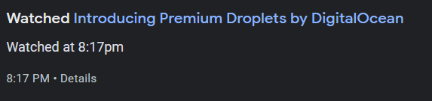

**April 5**

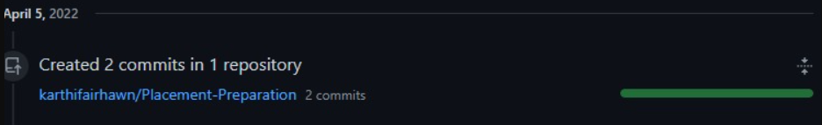

**Technical articles and blog read.**



 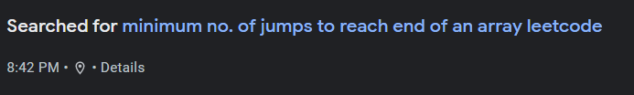

**April 6**

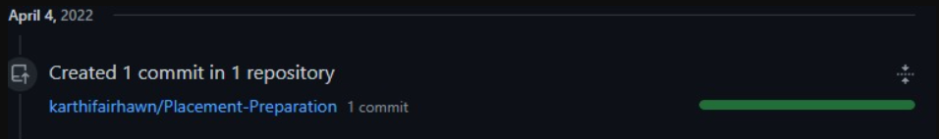

**LeetCode Submission**



**Technical articles and blog read.**



**April 7**

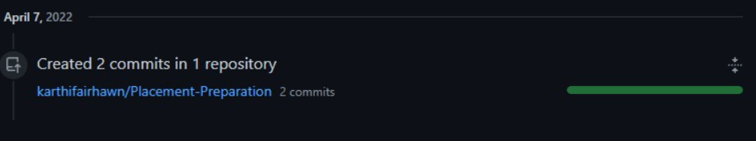

**LeetCode Submission**



**Technical articles and blog read.**



 

**April 8**

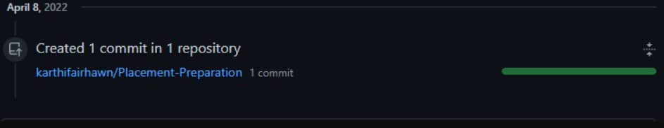

**Leetcode Submission**



**Technical articles and blog read.**







**April 9**

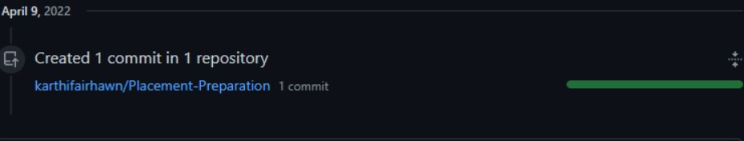

**Leetcode Submissions**



**Technical articles and blog read.**

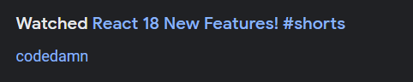

**April 10**

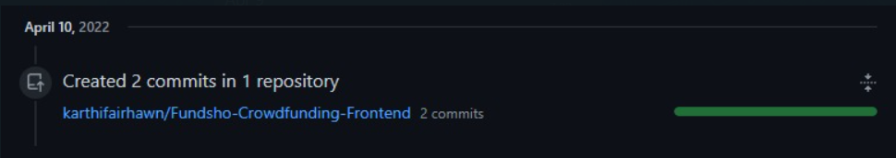

**Leetcode Submissions**



**Technical articles and blog read.**

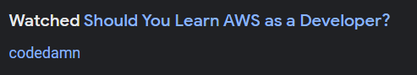



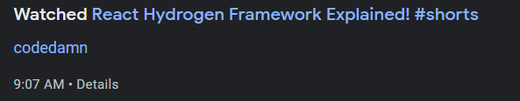

**April 11**

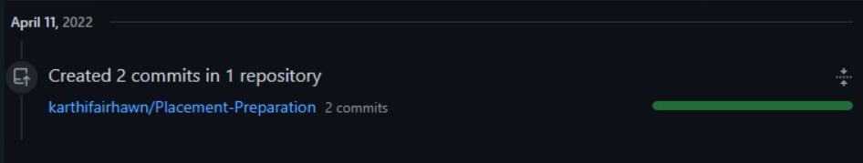

**Leetcode Submissions**



**April 12**

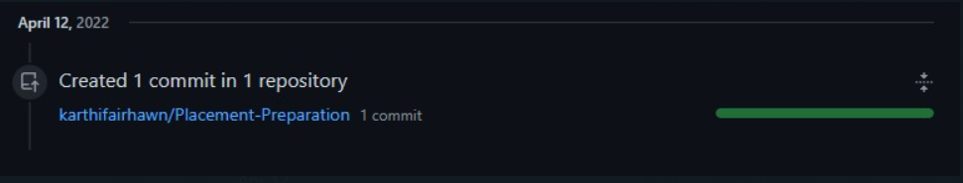

**Leetcode Submissions**



**Technical articles and blog read.**

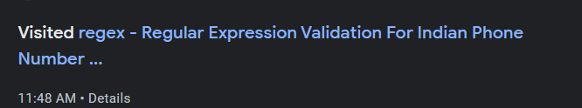

**April 13**

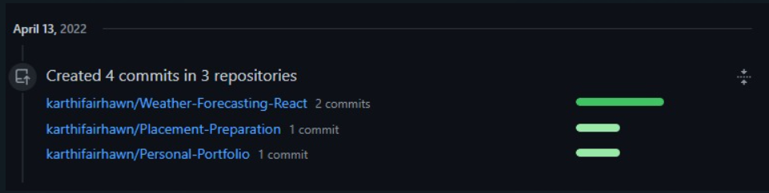

**Leetcode Submissions**



**Technical articles and blog read.**





  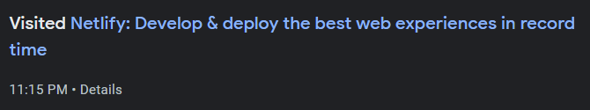 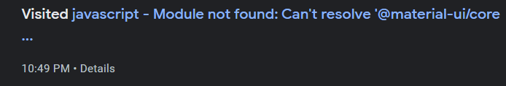

**April 14**

No Work

**April 15**

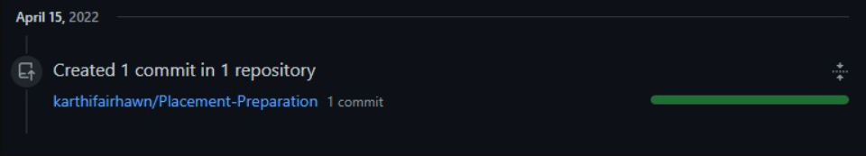

**Technical articles and blog read.**





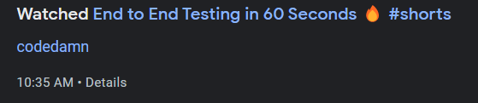

**April 16**

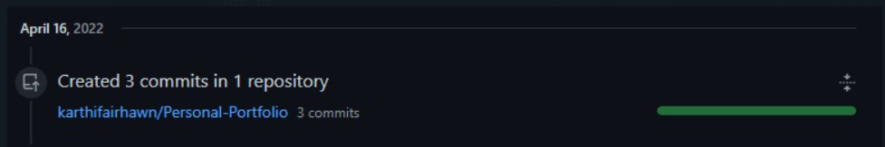

**April 17**

No work in GIT

**Technical articles and blog read.**

 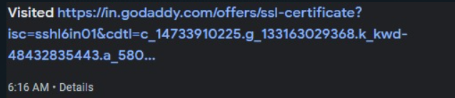

**April 18** 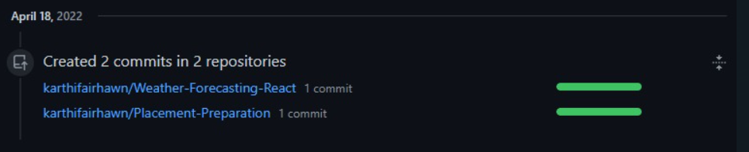

**Technical articles and blog read.**



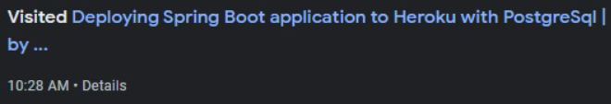





**April 19**

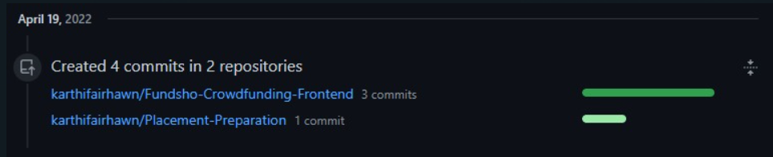

**Technical articles and blog read.**

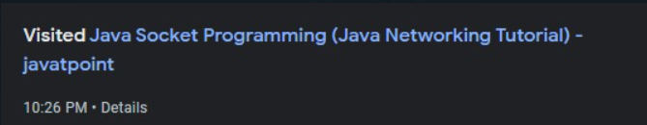

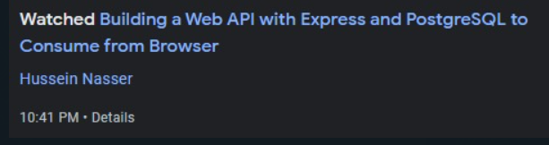



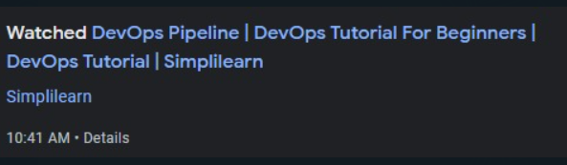

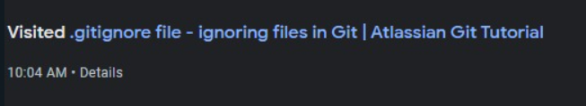

**April 20**

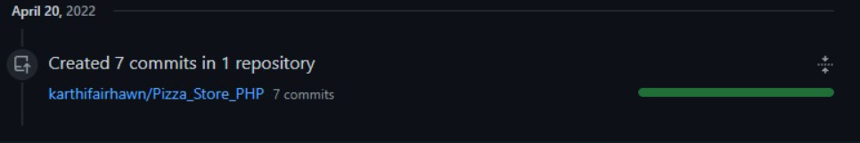

**Technical articles and blog read.**

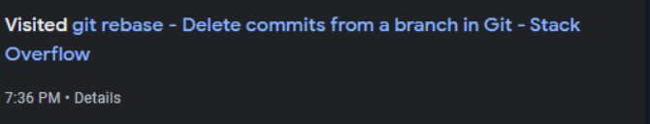

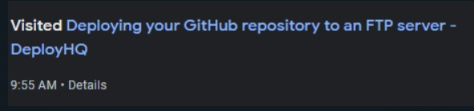





**April 21**

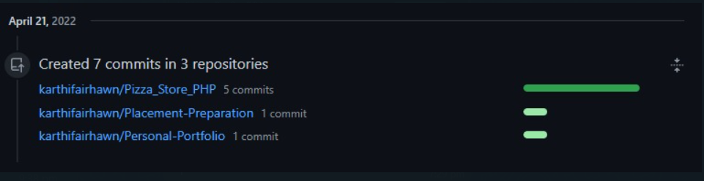

**Technical articles and blog read.**

 

**April 22**

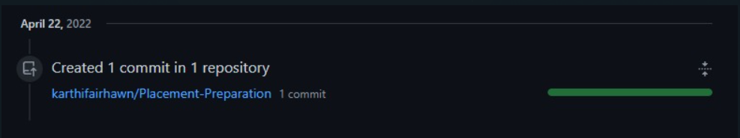

**Technical articles and blog read.**





**April 23**

No work

**April 24**

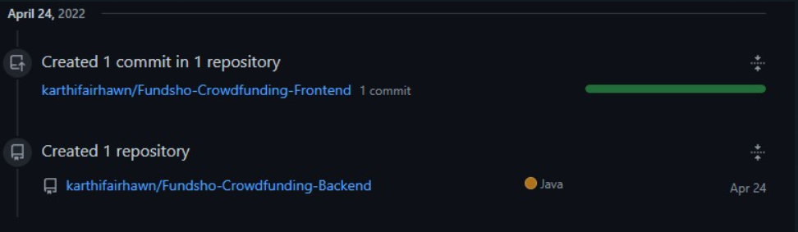

**Technical articles and blog read.**





**April 25**

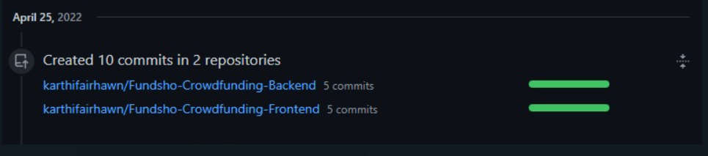

**Technical articles and blog read.**

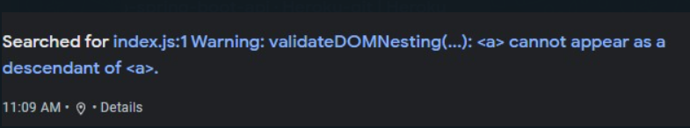



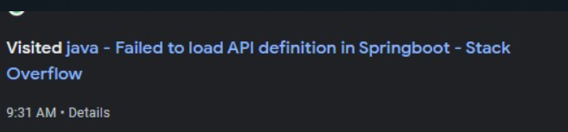



**April 26**

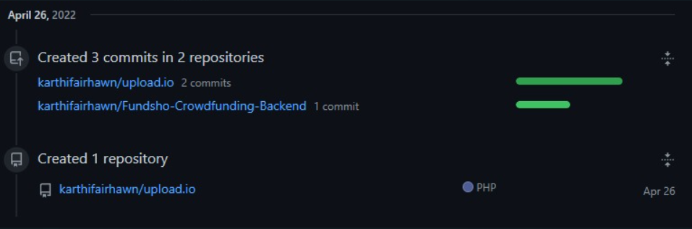

**Technical articles and blog read.**



 

**April 27**

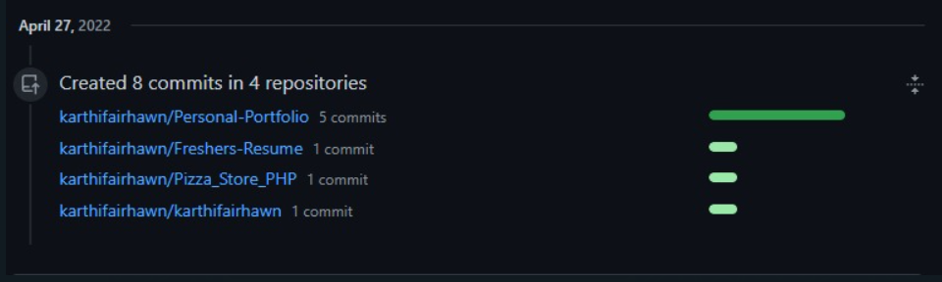

**Technical articles and blog read.**

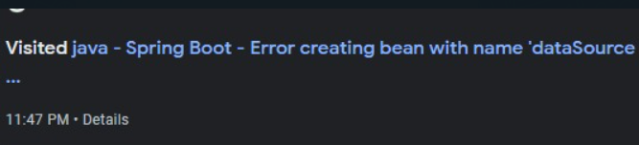





**April 28**

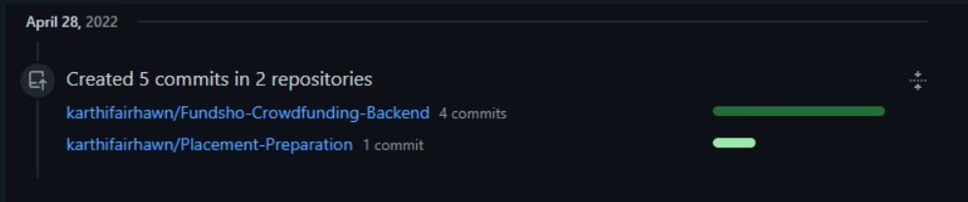

**Technical articles and blog read.**

 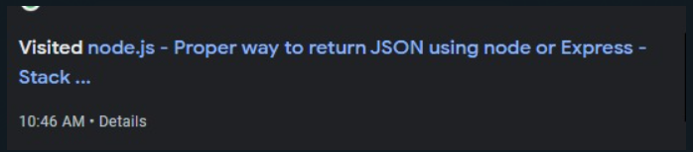  

**April 29**

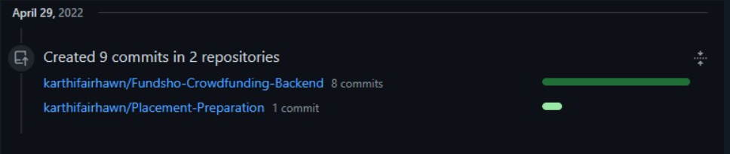

**Technical articles and blog read.**



 

**April 30**

No git work

**Technical articles and blog read.**









**May 1**

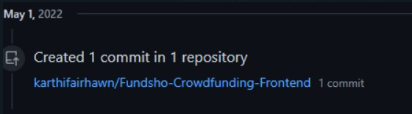

**Technical articles and blog read.**



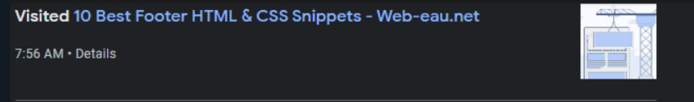

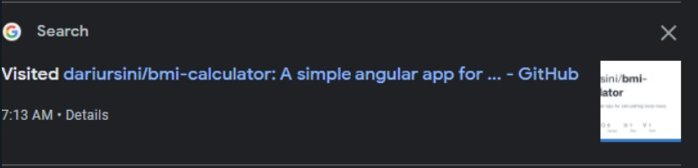

**May 2**

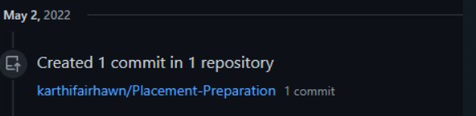

**Technical articles and blog read.**

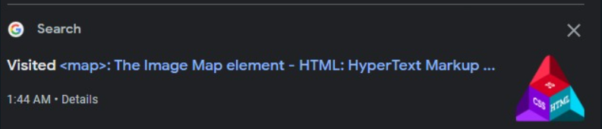

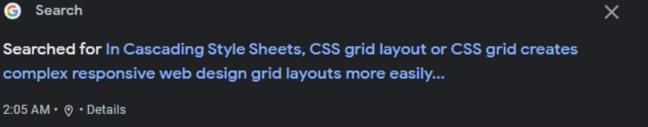

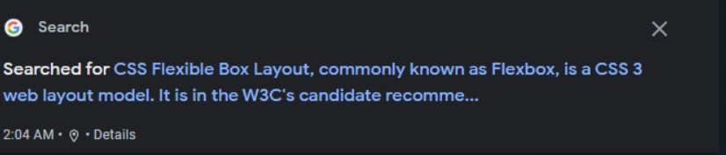

**May 3**

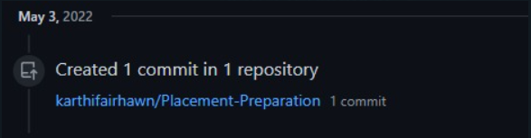

**Technical articles and blog read.**

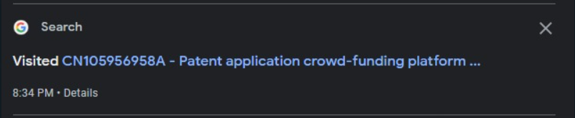

**May 4**

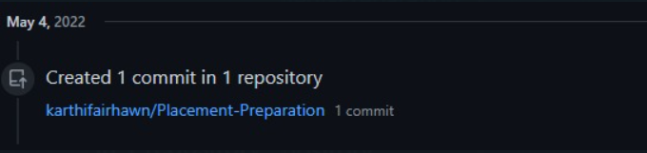

**Technical articles and blog read.**

 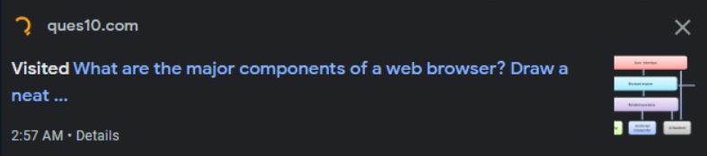



**May 5**

**No Work**

**May 6**

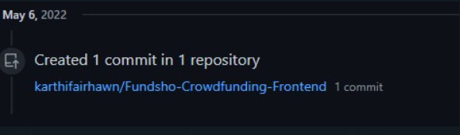

**Technical articles and blog read.**

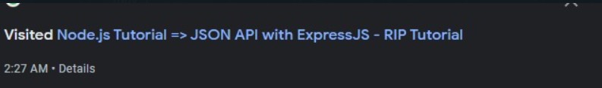

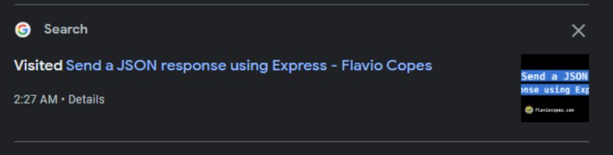

**May 7**

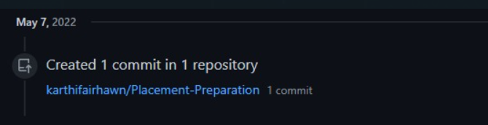

**May 8**

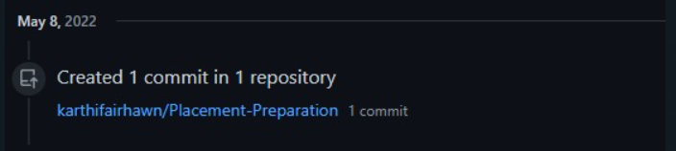

**May 9**

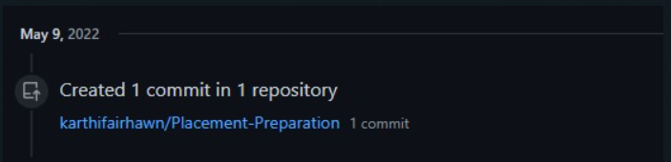

**Technical articles and blog read.**

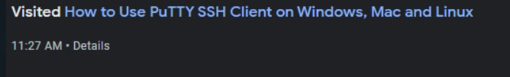

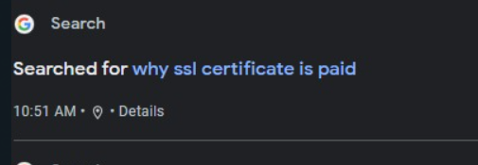



**May 10**

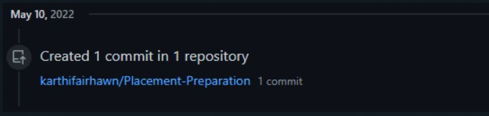

**Technical articles and blog read.**

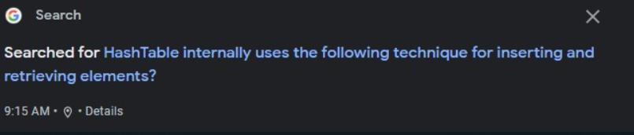

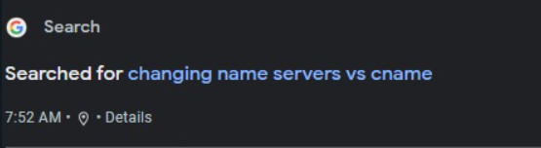

**May 11**

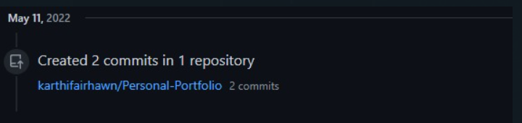

**Technical articles and blog read.**





**May 12**

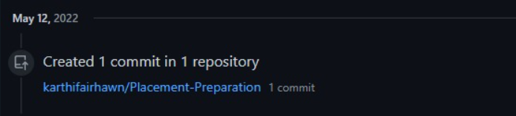

**Technical articles and blog read.**







**May 13**

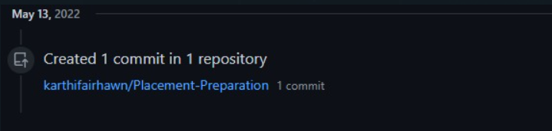

**Technical articles and blog read.**

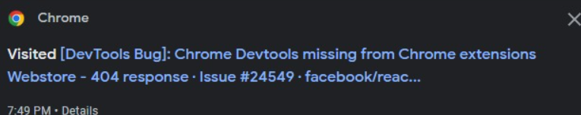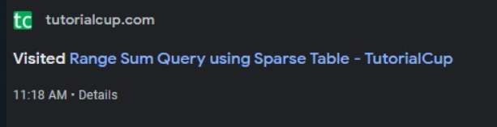

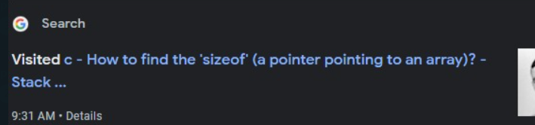

**May 14**

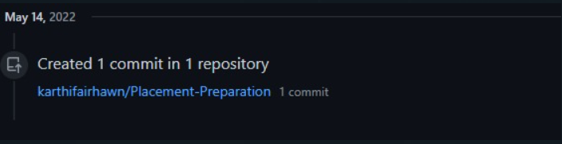

**May 15**

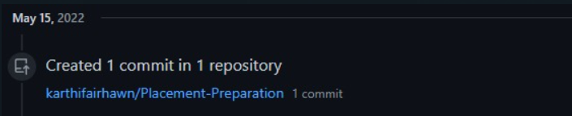

**Technical articles and blog read.**



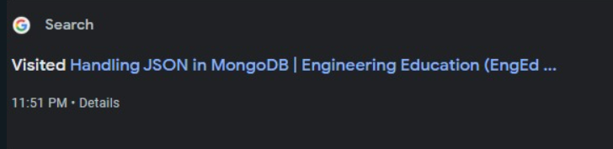

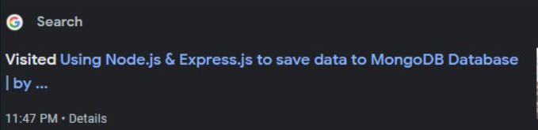

**May 16**

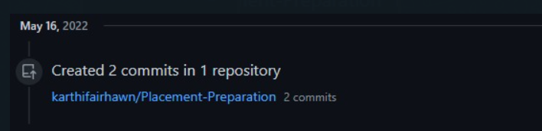

**Technical articles and blog read.**

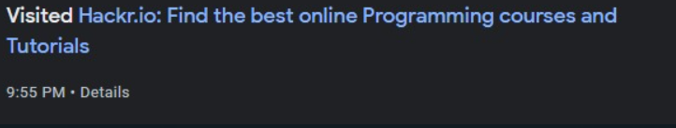

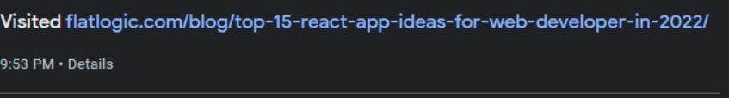

**May 17**

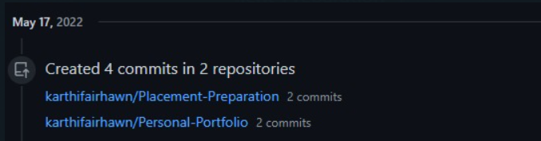

**Technical articles and blog read.**



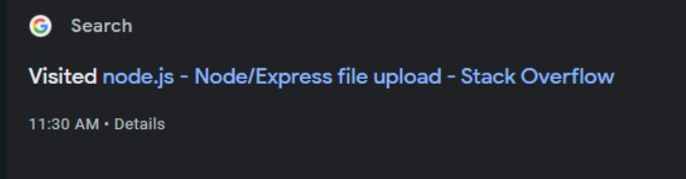



**May 18**

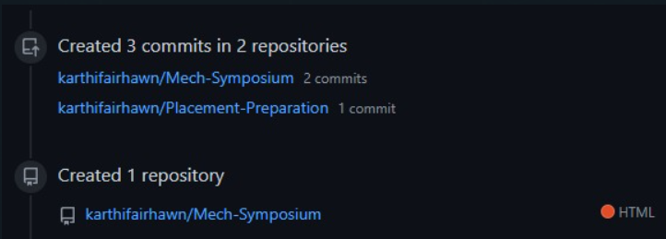

**Technical articles and blog read.**

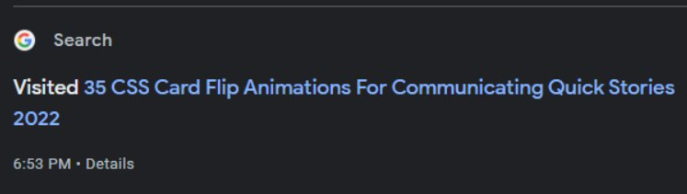



**May 19**

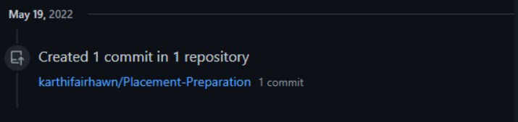

**May 20**

**No GIT Work**

**Technical articles and blog read.**

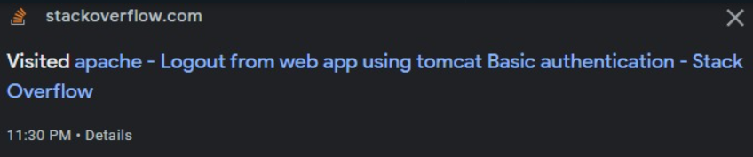

**May 21**

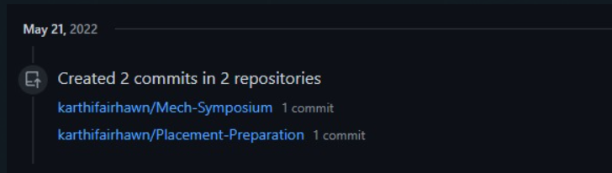

**Technical articles and blog read.**





**May 22**

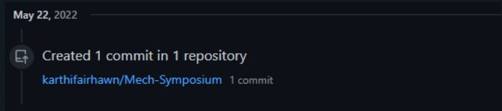

**May 23**

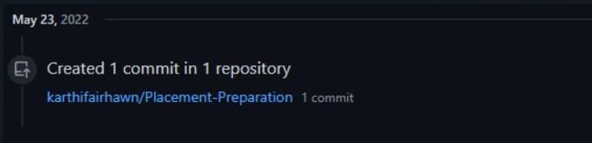

**Technical articles and blog read.**

 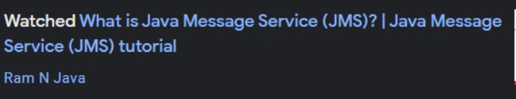

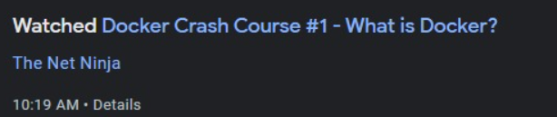

**May 24**

**Technical articles and blog read.**



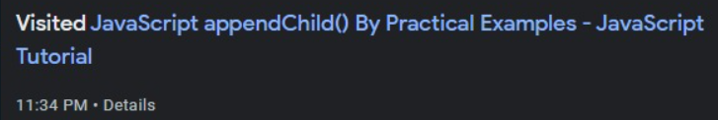



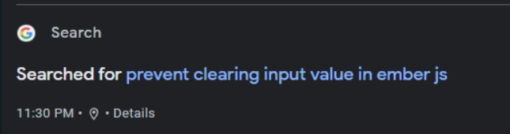

**May 25**

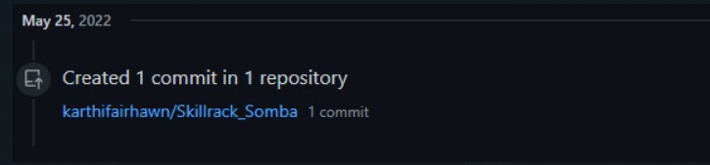

**May 26**

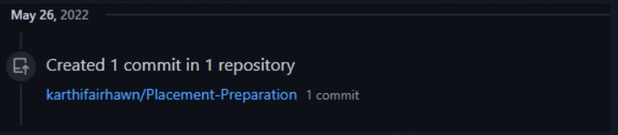 **Technical articles and blog read.**



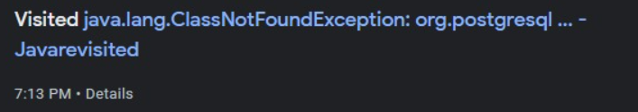



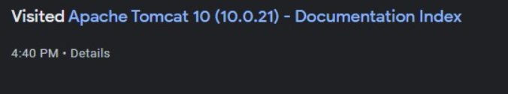

**May 27**

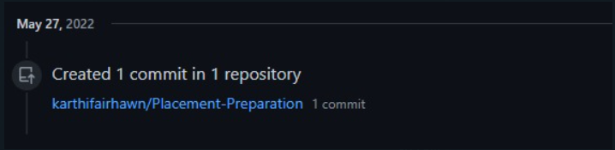

**Technical articles and blog read.**

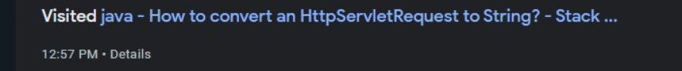





**May 28**

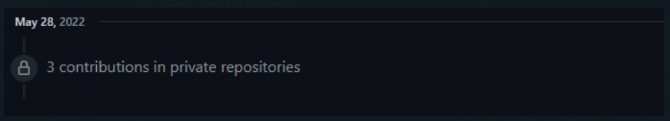

**May 29**

No Work

**May 30**

**Technical articles and blog read.**

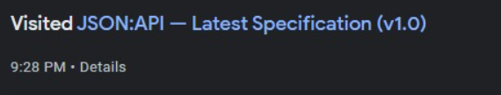



**May 31**

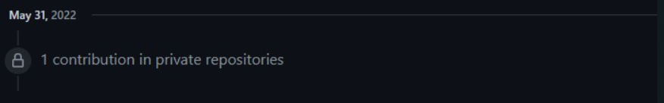

**June 1**

**Technical articles and blog read.**





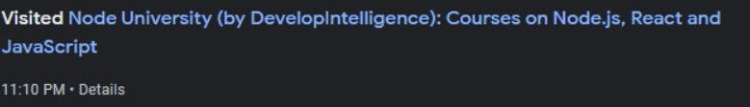

**June 2**

**Technical articles and blog read.**

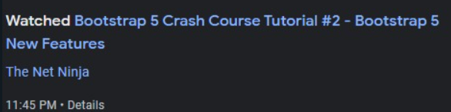



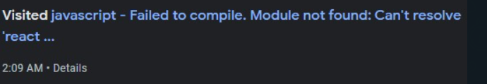



**June 3**

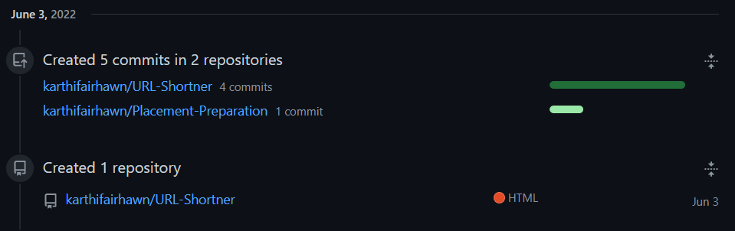

**June 4**

**No Work**

**June 5**

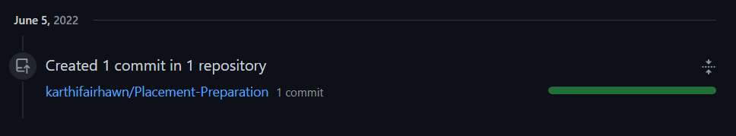

**June 6**

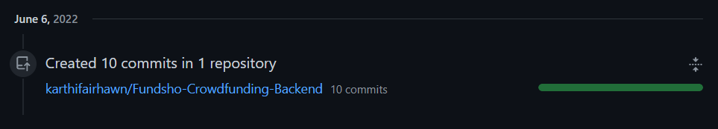

**Technical articles and blog read.**





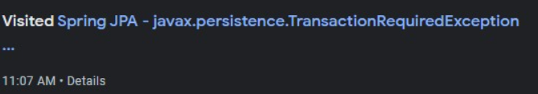

**June 7**

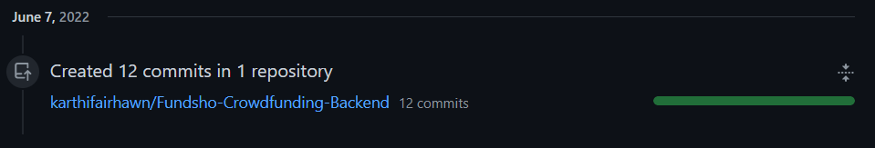

**Technical articles and blog read.**

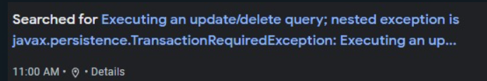

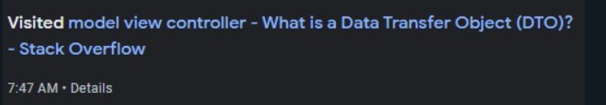 

**June 8**

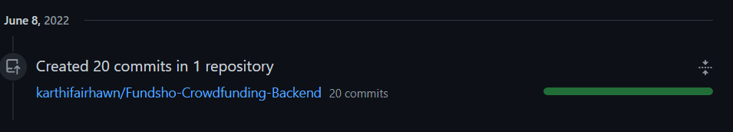

**Technical articles and blog read.**





**June 9**

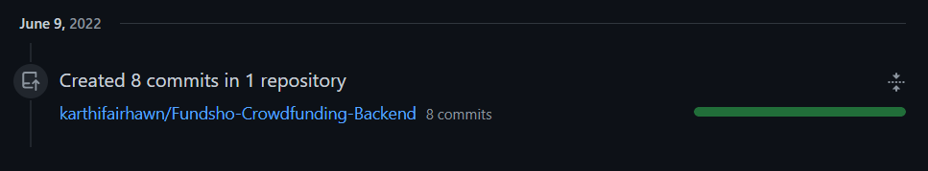

**Technical articles and blog read.**





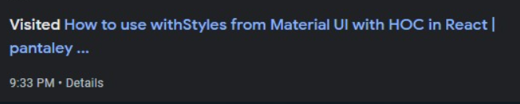



**June 10**

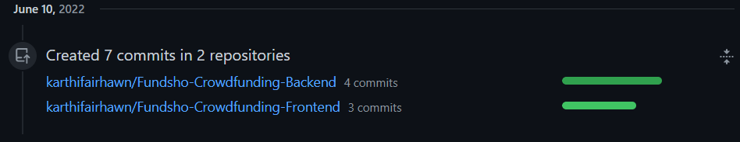

**Technical articles and blog read.**







**June 11**

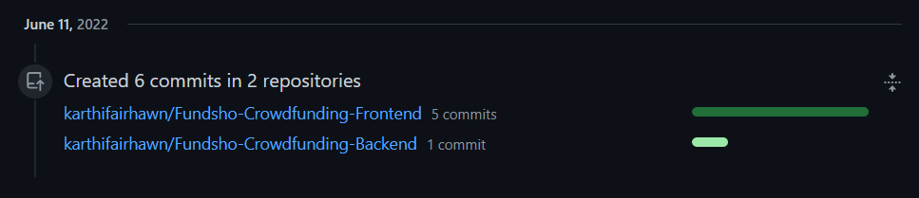

**Technical articles and blog read.**

 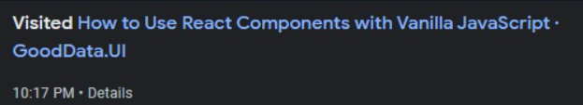 

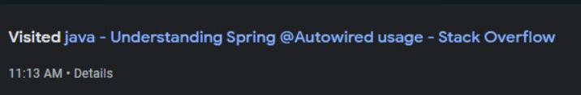

**June 12**

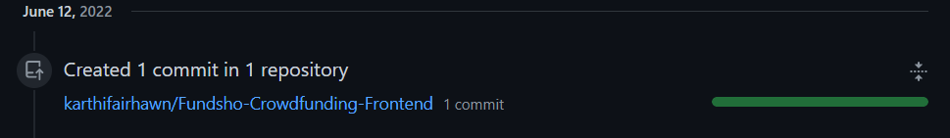

**Technical articles and blog read.**







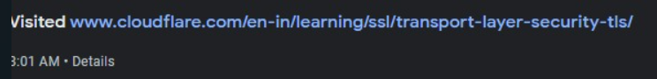



**June 13**

